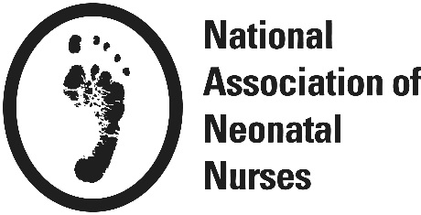REVIEW CRITERIA FOR EBP PROPOSALS
Each criteria listed below is scored on a 1-5 scale (1 = inadequate, 2 = below average, 3 = average, 4 = above average, 5 = superior). Components that are not applicable (N/A) for a given proposal are not included in the total possible score.
Proposal
Title & Abstract: Clearly & accurately reflects problem/purpose, methods & relevance of proposal
Background & Significance: Concise review and critique of current relevant empirical literature. Practice problem & significance to neonatal care clearly supported. Need for practice improvement justified.
Purpose of the Project: Clarity of purpose with well-defined & specific identification of outcomes.
Preliminary Data: Extent to which preliminary data/previous work relates to proposed practice change and demonstrates their capacity for completing the project.
Design: Extent to which the design addresses the project purpose. Specifies model and clearly describes specific steps/processes to be used to implement and evaluate the practice change.
Design: Incorporates preferences of population of interest and how barriers will be addressed
Sample: Clearly identified sample characteristics and rationale for sample size
Setting: Identified characteristics of the setting with support that desired sample can be recruited in clearly specified time frame
Outcomes and Measures: Clear description of each outcome measure, including number of items in the tool, scoring and range of responses. If using a standardized instrument includes reliability/validity or sensitivity/specificity information as appropriate.
Analysis of outcomes: Analytic plan is described for each specific outcome.
Timeline table: Clearly identifies in a table the activities that will occur over the funding period, including lines for planning, implementation steps of the practice change, data collection, data analysis, and preparations of manuscripts and/or presentations.
Data Plan: Clearly described plan for storing, managing & protecting data, including how data will be analyzed to address each research question/ hypothesis. Identifies a plan that assures statistical support
Dissemination: Describes a plan for disseminating findings, including expected impact on practice & research.
Human Subjects: Identifies, summarizes, and addresses potential risks to participants. If applicable, clearly outlines a plan for IRB approval from appropriate institution including how study personnel will obtain federally-required Training in the Responsible Conduct of Research
Reference List: Comprehensive list of all literature cited including key publications related to topic. Adherence to citation format specified for the NANN journal Advances in Neonatal Care
Consistency of topic with NANN mission and research agenda
Innovation: Extent to which proposal is innovative and shows originality
Feasibility: Extent to which project is feasible within the specified time frame, within limitations of project site for recruitment, and within budget and funding resources
Application is well-written & organized
Overall Quality Score of Research Plan
Personnel/Investigator Criteria
Principal Investigator/Co-Investigator Qualifications
Mentoring Plan: Identifies mentor/mentee with clear description of goals for the experience and frequency of meetings
Budget within Specified Limits
Budget Justification Appropriate
Institution & Team Commitment

